Article title, concise and informative title, concise and informative title, concise and informative title, concise and informative
The type of paper
FirstName LastName^{1*} , FirstName LastName ² and FirstName LastName ^{1,2}
¹ Department, Institution, City, Country
² Department, Institution, City, Country

*Corresponding author: yyyyyy@xxxxx.inst

Abstract. This is a sample abstract for submissions to Aurora: A Journal of Contemporary Science. The abstract should provide a concise yet comprehensive overview of the article. Authors must begin by introducing the research problem or topic, clearly stating its significance within the broader field. The aims or objectives of the study should follow, along with a brief explanation of the methods used. Any unique or interdisciplinary approaches applied in the research should be noted. The core findings of the study must be summarized, with emphasis on their relevance and originality. The authors should conclude the abstract by outlining the implications of the findings and how they contribute to future research, policy, or practice. The abstract should be written in clear and formal English, avoiding discipline-specific jargon and references. All abstracts must contain between 150 and 350 words and reflect the paper’s scope, novelty, and value to a multidisciplinary scientific audience and beyond.
Keywords: keyword1, keyword2, keyword3, keyword4, keyword5.

1. Example section one
All references presented in a reference list must be cited in the text of the manuscript, and all references cited in the text must be presented in the reference list. All figures and tables must be cited explicitly in the text. Examples of a figure and a table are shown in Figure 1 and Table 1. Authors must use the Harvard style for in-text citations and the reference list, which is described on the website (The Open University, 2025). Examples of proper journal article citations are (Kujala et al., 2019) and (Brynjolfsson, 2022). Studies (Binswanger, 2014), (Jin et al., 2013), and (MarineTraffic, 2025) are examples of citations for a book section, a conference paper, and a webpage.
Equations should be numbered continuously and be explicitly cited in the document, for example using structures like in Equation (1), in Eq. (1), or be embedded in the text of a sentence like shown here:
$$e=mc^{2} (1)$$
Section titles are flexible and not specified for any article type. The use of footnotes in the article is not recommended for references and in tables. The number of authors should not exceed ten.
Ipsum dolor sit amet, consectetur adipiscing elit. Nullam portion sapien nec ligula fermentum, vel dapibus lectus condimentum. Quisque convallis ultricies metus, non tincidunt lorem tincidunt a. Sed facilisis velit at augue suscipit, in efficitur tortor cursus.
Lorem ipsum dolor sit amet, consectetur adipiscing elit. Nullam porttitor sapien nec ligula fermentum, vel dapibus lectus condimentum. Quisque convallis ultricies metus, non tincidunt lorem tincidunt a. Sed facilisis velit at augue suscipit, in efficitur tortor cursus. Curabitur sit amet justo vitae sapien fringilla vestibulum. Phasellus eu blandit nisl. Integer tempor convallis neque, nec viverra velit commodo a. Vestibulum ante ipsum primis in faucibus orci luctus et ultrices posuere cubilia curae; In in erat sed velit hendrerit tincidunt non nec lorem.Mauris et orci. Aenean nec lorem. In porttitor. Donec laoreet nonummy augue. Suspendisse dui purus, scelerisque at, vulputate vitae, pretium mattis, nunc. Mauris eget neque at sem venenatis eleifend. Ut nonummy. Fusce aliquet pede non pede.
1.1 Example subsection one
In in erat sed velit hendrerit tincidunt non nec lorem.See the separate guidelines document for further information.
2. Example section two
2.1 Example subsection two
Lorem ipsum dolor sit amet, consectetur adipiscing elit. Nullam porttitor sapien nec ligula fermentum, vel dapibus lectus condimentum. Quisque convallis ultricies metus, non tincidunt lorem tincidunt a. Sed facilisis velit at augue suscipit, in efficitur tortor cursus. Curabitur sit amet justo vitae sapien fringilla vestibulum. Phasellus eu blandit nisl. Integer tempor convallis neque, nec viverra velit commodo a. Vestibulum ante ipsum primis in faucibus orci luctus et ultrices posuere cubilia curae; In in erat sed velit hendrerit tincidunt non nec lorem.
Suspendisse dapibus lorem pellentesque magna. Integer nulla. Donec blandit feugiat ligula. Donec hendrerit, felis et imperdiet euismod, purus ipsum pretium metus, in lacinia nulla nisl eget sapien. Donec ut est in lectus consequat consequat. Etiam eget dui. Aliquam erat volutpat. Sed at lorem in nunc porta tristique.
2.2 Example subsection three
Lorem ipsum dolor sit amet, consectetur adipiscing elit. Nullam porttitor sapien nec ligula fermentum, vel dapibus lectus condimentum. Quisque convallis ultricies metus, non tincidunt lorem tincidunt a. Sed facilisis velit at augue suscipit, in efficitur tortor cursus. Curabitur sit amet justo vitae sapien fringilla vestibulum. Phasellus eu blandit nisl. Integer tempor convallis neque, nec viverra velit commodo a. Vestibulum ante ipsum primis in faucibus orci luctus et ultrices posuere cubilia curae; In in erat sed velit hendrerit tincidunt non nec lorem.

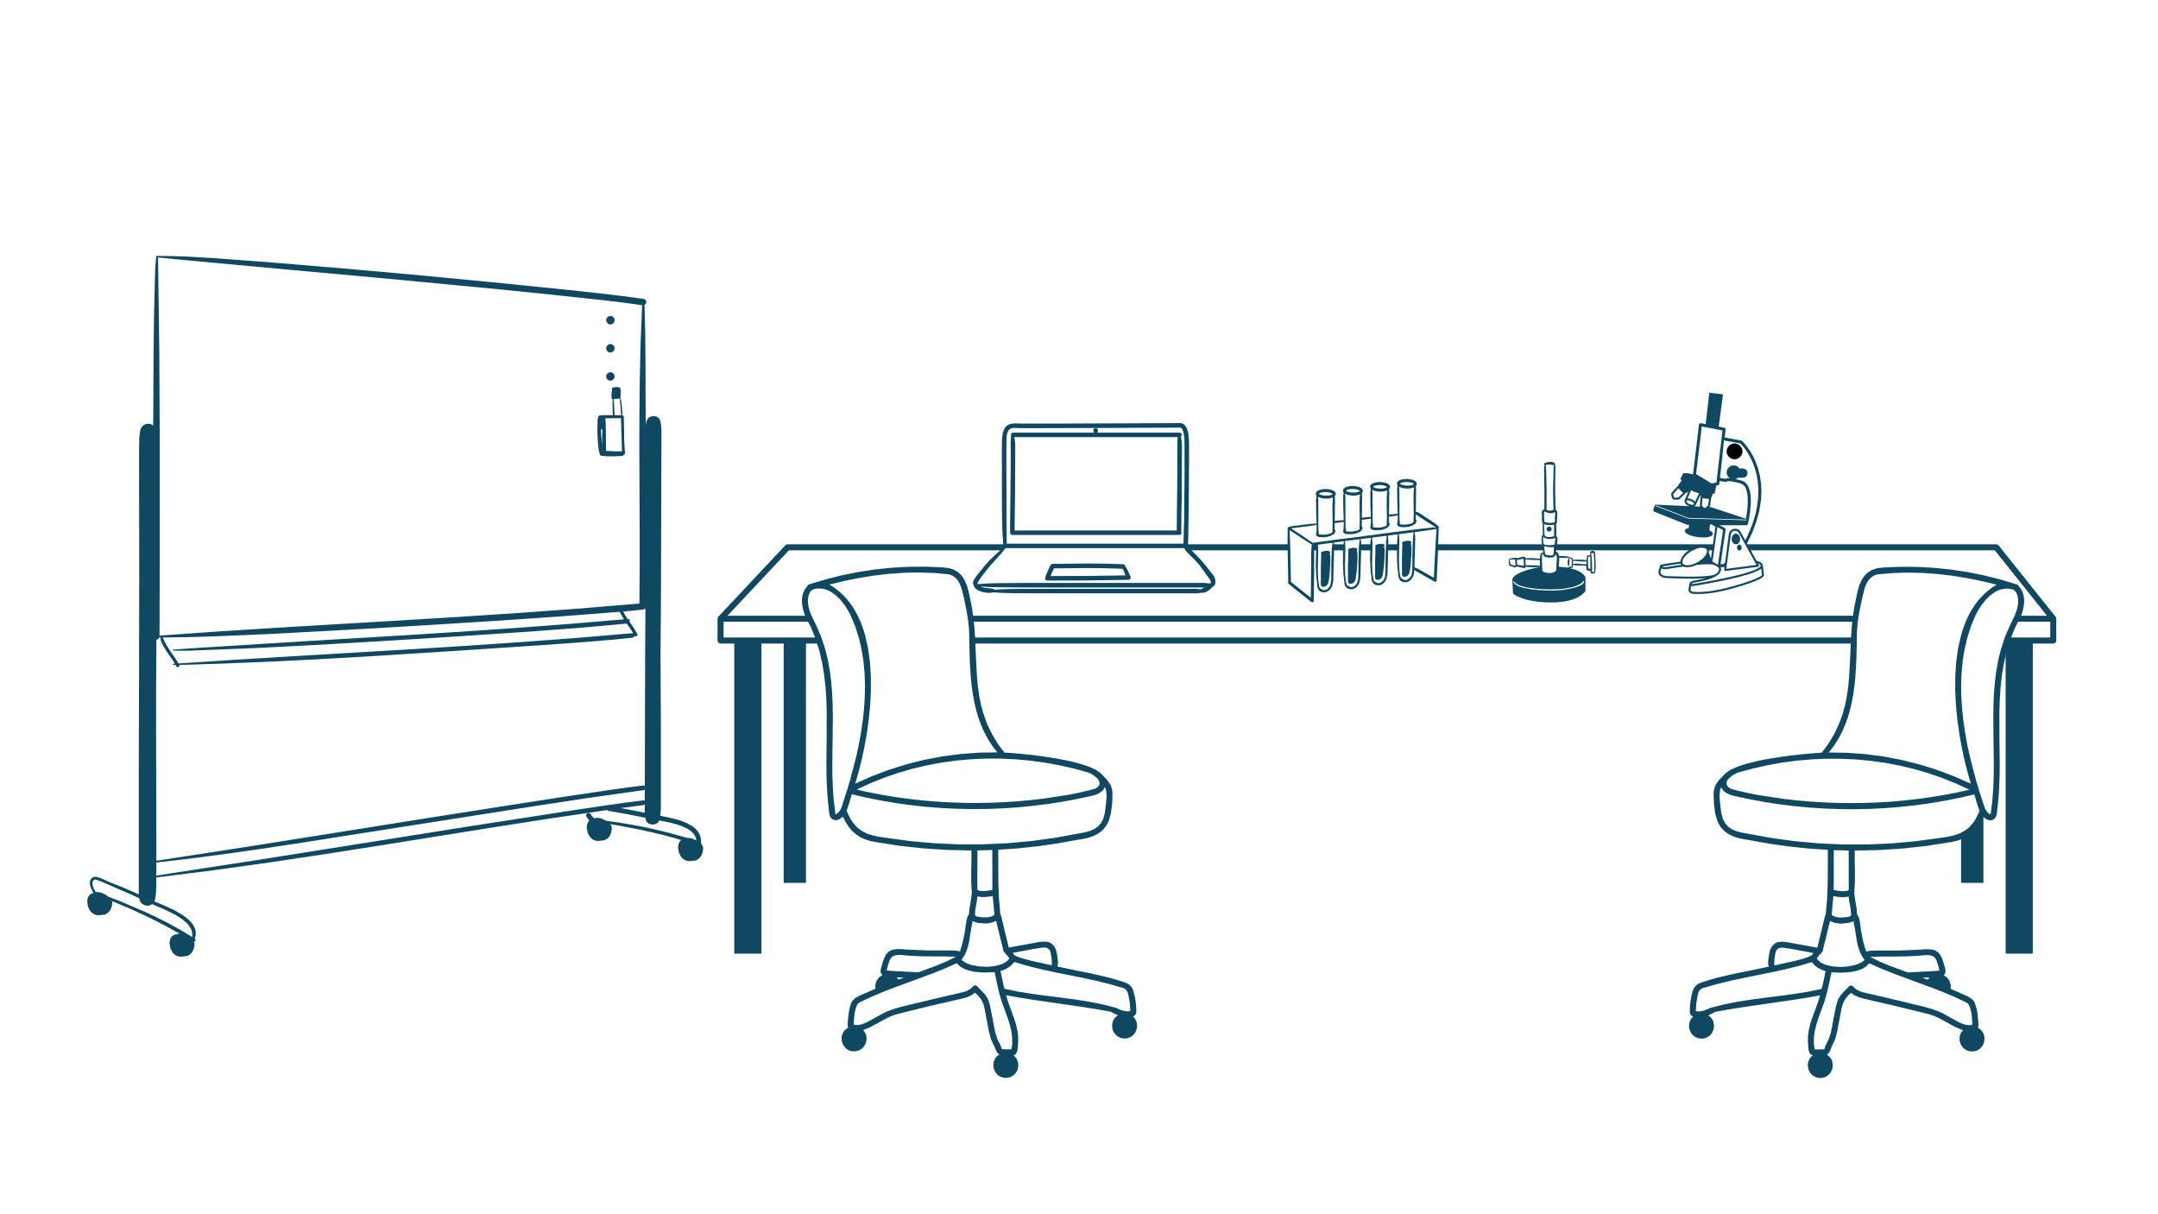
Figure 1. Here you should place a description of Figure 1. The description of the figure must be concise and informative. The figure with description should be understandable on its own without reading the article text.
Table 1. Here you should place a description of Table 1. The description of the table must be concise and informative. The table with description should be understandable on its own without reading the article text.
Column heading | Column heading | Column heading | Column heading
Data row 1 | 1.0 | 1.5 | 2.0
Data row 2 | 2.0 | 2.5 | 3.0
Data row 3 | 3.0 | 3.5 | 4.0

Lorem ipsum dolor sit amet, consectetur adipiscing elit. Nullam porttitor sapien nec ligula fermentum, vel dapibus lectus condimentum. Quisque convallis ultricies metus, non tincidunt lorem tincidunt a. Sed facilisis velit at augue suscipit, in efficitur tortor cursus. Curabitur sit amet justo vitae sapien fringilla vestibulum. Phasellus eu blandit nisl. Integer tempor convallis neque, nec viverra velit commodo a. Vestibulum ante ipsum primis in faucibus orci luctus et ultrices posuere cubilia curae; In in erat sed velit hendrerit tincidunt non nec lorem.
Lorem ipsum dolor sit amet, consectetur adipiscing elit. Nullam porttitor sapien nec ligula fermentum, vel dapibus lectus condimentum. Quisque convallis ultricies metus, non tincidunt lorem tincidunt a. Sed facilisis velit at augue suscipit, in efficitur tortor cursus. Curabitur sit amet justo vitae sapien fringilla vestibulum. Phasellus eu blandit nisl. Integer tempor convallis neque, nec viverra velit commodo a. Vestibulum ante ipsum primis in faucibus orci luctus et ultrices posuere cubilia curae; In in erat sed velit hendrerit tincidunt non nec lorem.
Pellentesque libero lectus, tristique ac, consectetuer sit amet, imperdiet ut, justo. Sed aliquam odio vitae tortor. Proin hendrerit tempus arcu. In hac habitasse platea dictumst. Suspendisse potenti. Vivamus vitae massa adipiscing est lacinia sodales. Donec metus massa, mollis vel, tempus placerat, vestibulum condimentum, ligula. Nunc lacus metus, posuere eget, lacinia eu, varius quis, libero.
Proin pharetra nonummy pede. Mauris et orci. Aenean nec lorem. In porttitor. Donec laoreet nonummy augue. Suspendisse dui purus, scelerisque at, vulputate vitae, pretium mattis, nunc. Mauris eget neque at sem venenatis eleifend. Ut nonummy. Lorem ipsum dolor sit amet, consectetur adipiscing elit. Nullam porttitor sapien nec ligula fermentum, vel dapibus lectus condimentum. Quisque convallis ultricies metus, non tincidunt lorem tincidunt a. Sed facilisis velit at augue suscipit, in efficitur tortor cursus. Curabitur sit amet justo vitae sapien fringilla vestibulum. Phasellus eu blandit nisl. Integer tempor convallis neque, nec viverra velit commodo a. Vestibulum ante ipsum primis in faucibus orci luctus et ultrices posuere cubilia curae.
References
Binswanger, M., 2014. Excellence by Nonsense: The Competition for Publications in Modern Science, in: Bartling, S., Friesike, S. (Eds.), Opening Science: The Evolving Guide on How the Internet Is Changing Research, Collaboration and Scholarly Publishing. Springer International Publishing, Cham, pp. 49–72. https://doi.org/10.1007/978-3-319-00026-8_3
Brynjolfsson, E., 2022. The Turing Trap: The Promise & Peril of Human-Like Artificial Intelligence. Daedalus 151, 272–287. https://doi.org/10.1162/daed_a_01915
Jin, Y., Kan, M.-Y., Ng, J.-P., He, X., 2013. Mining Scientific Terms and their Definitions: A Study of the ACL Anthology, in: Proceedings of the 2013 Conference on Empirical Methods in Natural Language Processing. Presented at the EMNLP 2013, Association for Computational Linguistics, Seattle, Washington, USA, pp. 780–790.
Kujala, P., Goerlandt, F., Way, B., Smith, D., Yang, M., Khan, F., Veitch, B., 2019. Review of risk-based design for ice-class ships. Marine Structures 63, 181–195. https://doi.org/10.1016/j.marstruc.2018.09.008
MarineTraffic, 2025. MarineTraffic: Global Ship Tracking Intelligence [WWW Document]. URL https://www.marinetraffic.com/en/ais/home/centerx:29.2/centery:43.1/zoom:8 (accessed 1.10.25).
The Open University, 2025. Quick guide to Harvard referencing (Cite Them Right) [WWW Document]. URL https://university.open.ac.uk/library/referencing-and-plagiarism/quick-guide-to-harvard-referencing-cite-them-right (accessed 6.9.25).

